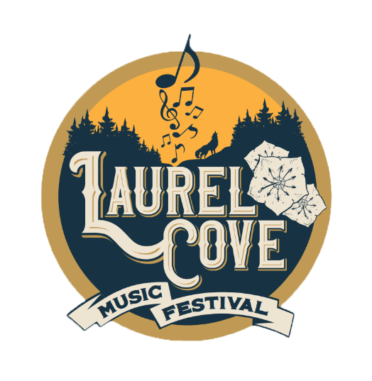
Volunteer Request

Name: ____________________________
Phone Number: _____________________
Email:________________________
Date of birth: _______________________

List any Emergency Contacts and their cell phone number: _________________________________

List any jobs you would prefer to help at (ie green room food, decorating, stage hand, etc)?:
_____________________________________________________________________________________

List any events you have volunteered at before:
_____________________________________________________________________________________

Are you able to lift heavier objects between 50-70 lbs?: ________________________

Signature: ___________________________________________________
Please send filled out form to jon@bellcountytourism.com
By signing this form, I agree to hold Laurel Cove, along with all its partners, volunteers, sponsors, and all other related entities not liable in the case that any personal injury or loss of personal property. If you are asked to do any task for which you do not feel you are physically or mentally able to do, simply let the staff know and do not attempt. Please note that very few volunteers we don’t know are accepted and that this isn’t a free pass to come and watch the entire show and not work. We need every volunteer we have to help this event go smoothly. Thanks so much for offering to help!

