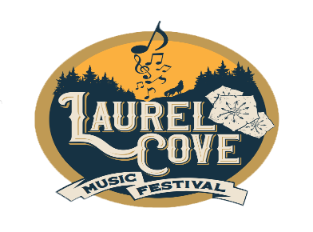
2023 Sponsor Packet
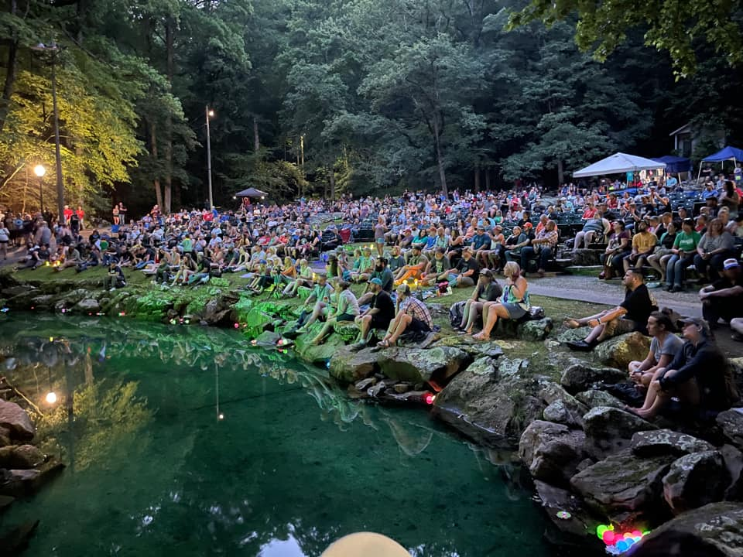#MusicBloomsHere
To Whom It May Concern:

My name’s Jon Grace, and I’m the Director of Tourism here in Bell County, KY (Middlesboro/Pineville/Cumberland Gap Area). I’m writing to you in hopes you'll consider coming on board as a sponsor for our 2023 Laurel Cove Music Festival, which takes places on June 9th and 10th, 2023 at Pine Mountain State Resort Park in Pineville, KY. The event is a collaboration between Bell County Tourism, Main Street Pineville, and Pine Mountain State Resort Park and has become a signature event for our area in four short years. The venue of the festival, Laurel Cove Amphitheater, is absolutely jaw-dropping. Seating over 1,300 people, it is best known as the location of the Kentucky Mountain Laurel Festival Queen’s Coronation. It’s been under-utilized as a concert venue in the past, but this event has changed that narrative. Built by the CCC in the 1930s in Kentucky’s oldest state park, Laurel Cove Amphitheater is gaining buzz around the country as a must-see live music destination. With a rock cliff behind the stage, a pond in front of it, and old growth hemlock and rhododendron all around, seeing a show here is a completely unique experience. Not only aesthetically…the acoustics for this venue are also out of this world. It’s an Appalachian dreamscape come to life, one that immediately makes you feel comfortable and at home, and in my opinion (and many others), there isn’t a better place to watch a live show.
Each year, more and more people are discovering the magic of Laurel Cove. We have had folks from 22 states and 3 foreign countries. The goal of Laurel Cove Music Festival is simple: to bring our audience the best up and coming talent from Appalachia and beyond to our home in the mountains of southeast Kentucky. We may never be able to afford the Chris Stapleton’s or Tyler Childers’ of the world, but we are bringing our audience the next generation of talent before they are filling arenas. The chance to get to see future stars in an intimate and magical outdoor venue like Laurel Cove Amphitheater is what makes this event so incredibly special. Acts like Morgan Wade, Lost Dog Street Band, Charles Wesley Godwin, 49 Winchester, Sierra Ferrell and many more are just a few of the acts that have played our lineup in the past and are now making major waves with their careers.

For 2023, we are planning on taking things up a notch more, both with our lineup AND our marketing efforts. With some help from the American Rescue Plan, the state is giving us $25,000 in free advertising which we’ll be using mainly on promoting Laurel Cove. That makes this the best year ever to sponsor, because we are using this increased advertising to help promote the companies and organizations that are sponsoring us. The Kentucky music scene is unlike any in the country right now, and Laurel Cove Music Festival has quickly become one of its staple events. We are happy we can promote it in so many ways this year, and pass that benefit on to our sponsors. Our lineup will be taken up a notch every single year, and through the help of sponsors we are able to keep the prices on this amazing festival as low as any in the state, despite having such amazing talent. We also make sure to go above and beyond when it comes to reciprocating the support your company gives to this festival by promoting it in a myriad of ways, which are detailed in this packet.

We’re not the biggest or most flashy festival in the state. But as far as smaller and medium sized festivals, people think we’re top shelf, as you can see from the few reviews I’ve attached from previous years. We know we have something very special in our mountains with this festival, and we hope that you can find a way to help us continue growing what’s becoming one of our states most talked-about music festivals.
Thanks so much for your consideration!
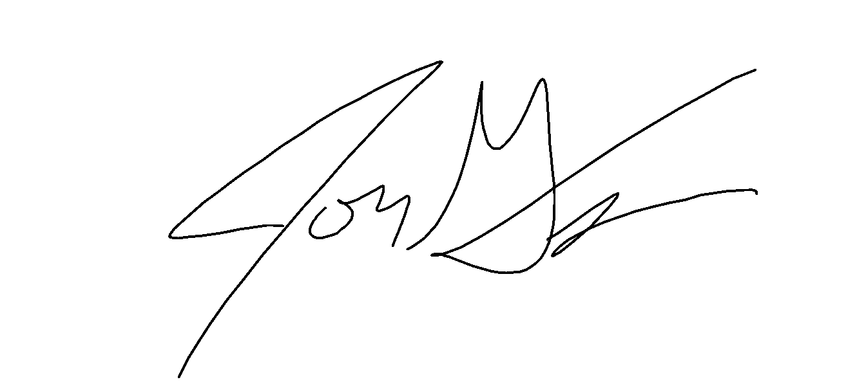
Jon Grace / Bell County Tourism Director
Cell: 606-499-0567/ Email: jon@bellcountytourism.com / FB: www.facebook.com/LaurelCoveMusicFestival
We know that your company is constantly bombarded with sponsorship requests, and in today’s economy we also know every dollar must be wisely spent…especially marketing and community development dollars. That’s why it’s important to sponsor events that will be well attended (which this event will be), events that help other non-profits (which ours does, such as ROHO and Bell County Animal Shelter), and events that will go the extra mile to make sure your generosity is recognized. Each sponsor level has the benefits listed below. There are also additional sponsorship opportunities listed on following page.
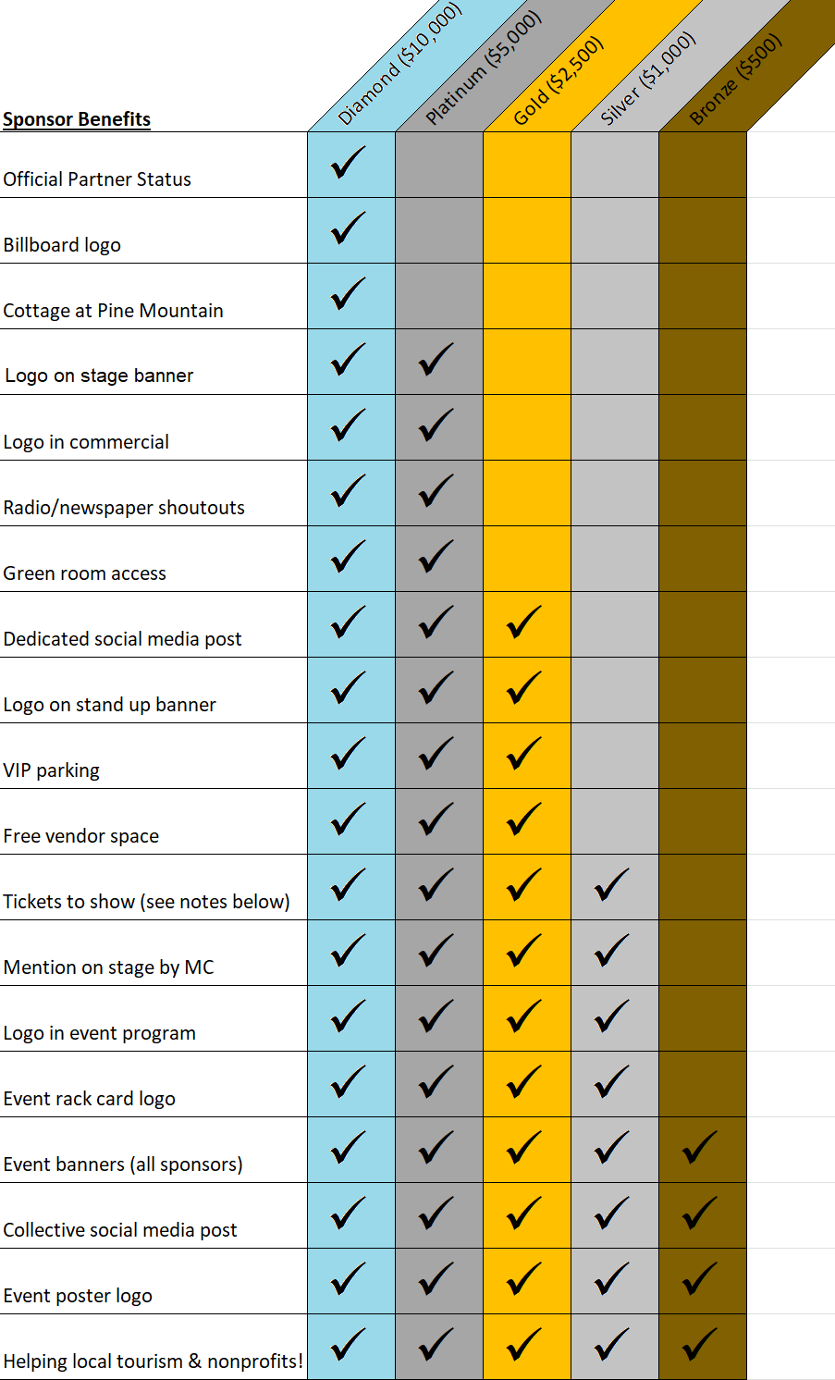
Both Bell County Tourism and Main Street Pineville will be putting forth financial contributions much more than any sponsorship level, and we will limit our sponsors to only one Diamond sponsor ($10,000), four at the Platinum ($5,000) level, six companies at Gold ($2,500)), and ten at the Silver ($1,000) and Bronze ($500) levels.
Notes on Sponsor Levels:
- Will need high resolution logo in PNG format (contact if you do not have one and we will make you on, free of charge!)
- Cottage will be for nights of June 9th and 10th and sleeps 5 (2 bedrooms/4 beds and a couch).
- Logos will be placed in respect to order to sponsor level (Ie. Diamond sponsors have top/largest logos, Platinum second tier/next largest, etc.…)
- Bronze level will be represented in text, not logo for space saving reasons.
- If your company needs a vendor space, please let us know ASAP (Deadline is April 30th, 2023).
- Each level also comes with the following amounts of free tickets:
  - Diamond (10 tickets), Platinum (6 tickets), Gold (4 tickets), Silver (2 tickets)
Additional Sponsorship Opportunities
We also have several unique variations of our sponsorship levels, which a company may choose to pursue instead of one of the standard ones. Each of these levels is broken down below. If alternative means of donating is listed (like equal value of needed product), remember that product will be specified by the Festival Committee as to exactly what is needed.
Creekside Stage Sponsor - $5,000. Sponsor benefits equal to Platinum Package. Additional benefit includes company banner placed at the Creekside Stage at Laurel Cove Music Festival. The Creekside, while it is our secondary stage, is hugely popular and has seen some massive crowds since its inception in 2021. Artists like Cole Chaney, Vincent Neil Emerson, Abby Hamilton, Logan Halstead and many more have had legendary performances with crowds of 300 plus people at it.
Green Room/Band Area Sponsor - $2,500 or equal value of needed product. Sponsor benefits are equal to Gold Package. This donation can be made monetarily or with food and drink to be supplied to the Green Room and Band Areas at the Festival (or with a combination of each). We will also allow this sponsor a banner to be placed at both areas during the festival. The food and drink MUST be what is ordered by festival committee, any variations need to be approved by festival committee or Jon Grace with Bell County Tourism. We will provide list at least 2 week out of all food and drinks needed
Hospitality Sponsor - $2,500 or 20 double hotel rooms. Sponsor benefits are equal to the Gold Package. To help mitigate our lodging costs for bands, we are also including a hospitality level sponsorship which can be donated to with free rooms up to $2,500 in value (or twenty double rooms), or a monetary donation to pay for these. If this is a local hotel, we will make a separate social media post and website section acknowledging you as the Official Hospitality Sponsor for Laurel Cove, recommend people to stay here first and foremost, and also provide a free shuttle service from the event to your hotel.
Event Program Sponsorship – 1,000 Event Programs. Benefits will be equal to Gold Level sponsorship. Our goal is to create a program this year for folks to keep and look back on with artist bios, festival information, tons of pictures, a few autograph pages, etc. This program will be designed by the festival committee and turned in to the sponsor company no later than March 15. We can also discuss at-cost sponsorship for a lower tier of sponsorship package equivalent.
Event Banner Sponsorship – $1,000 to $2,500 or equal value of needed product (vinyl banners, yard signs, etc.). Sponsor benefits equal to either Silver or Gold Package. This will be the only special category that may have two sponsors, depending on what level is sponsored at. We will need various vinyl banners (around six 6’x12’), yard signs, and a few more similar items.
Event Rack Card/Poster Sponsorship – $1,000 to $2,500 or equal value of needed product. Sponsor Benefits from Silver ($1,000) to Gold ($2,500) level. We will need several hundred event posters (11x17” and a few 18x24”) and several thousand rack cards made to promote the festival. We can accommodate a sponsorship on either level.
VIP Area Sponsor – $1,000. Benefits will be equal to Silver Level sponsorship, and a company banner will be allowed to be placed in VIP area. We sell around 150 VIP tickets every year, that comes with certain extra perks like parking, special edition posters, premium seating and much more. We also have a special VIP area off the side of the stage with tables filled with snacks, water, private restrooms, etc. This sponsorship will be to pay for the VIP area amenities.

Sample Poster/ Rack Card / Stand Up Banner Event Program
(1,000 posters and 5,000 rack cards (1,000 Printed)
printed, along with 5-6 stand up banners).
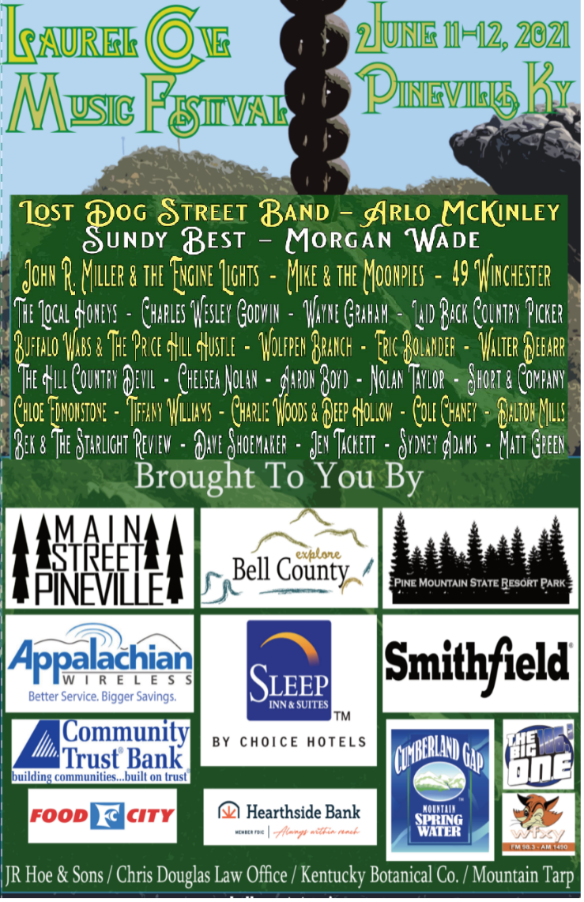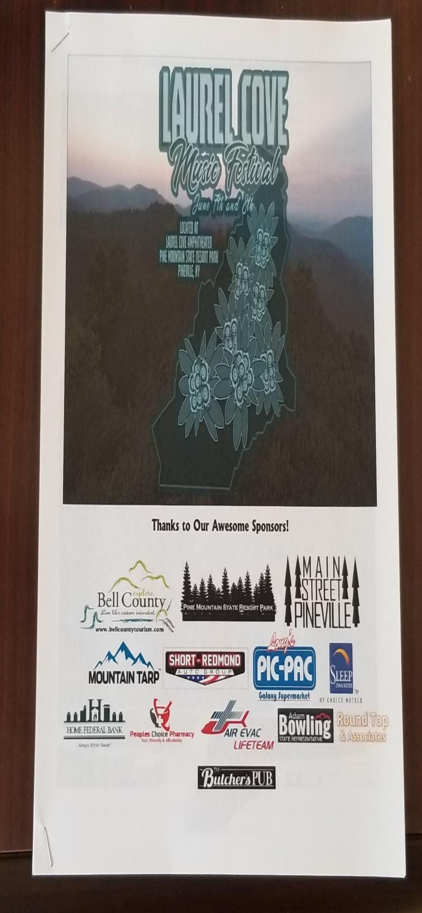
Event Banners On Stage
One of six (6) 12’x4’ banners promoting our sponsors Social Media Shoutouts Throughout Year
from last year hung prominently throughout event.
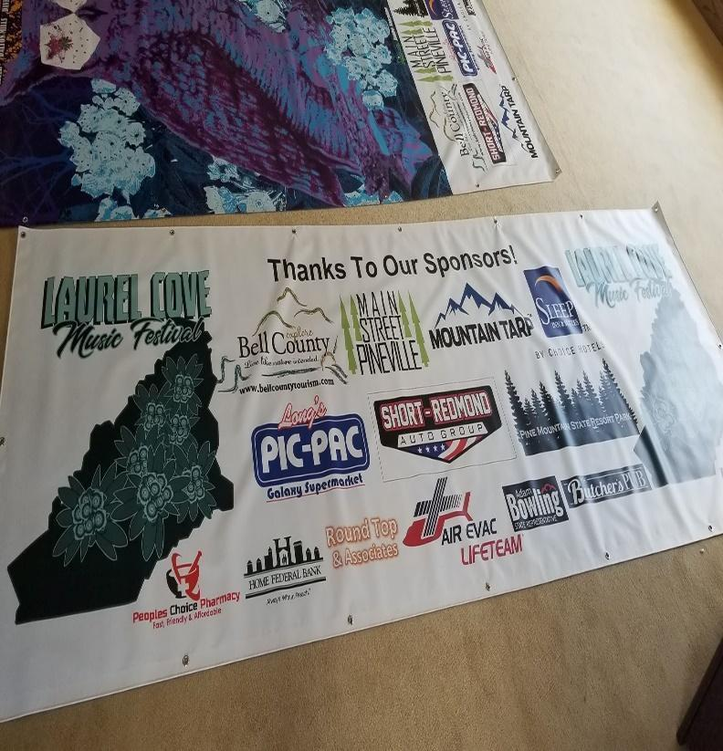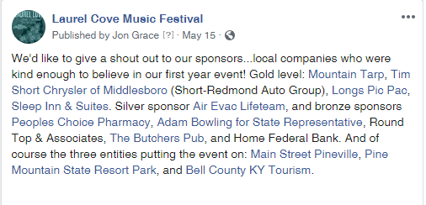

Closing shot of commercial that aired throughout state last year as part of a $5,000 TV marketing campaign and is also on Facebook (https://www.facebook.com/LaurelCoveMusicFestival/videos/298080784459877/)
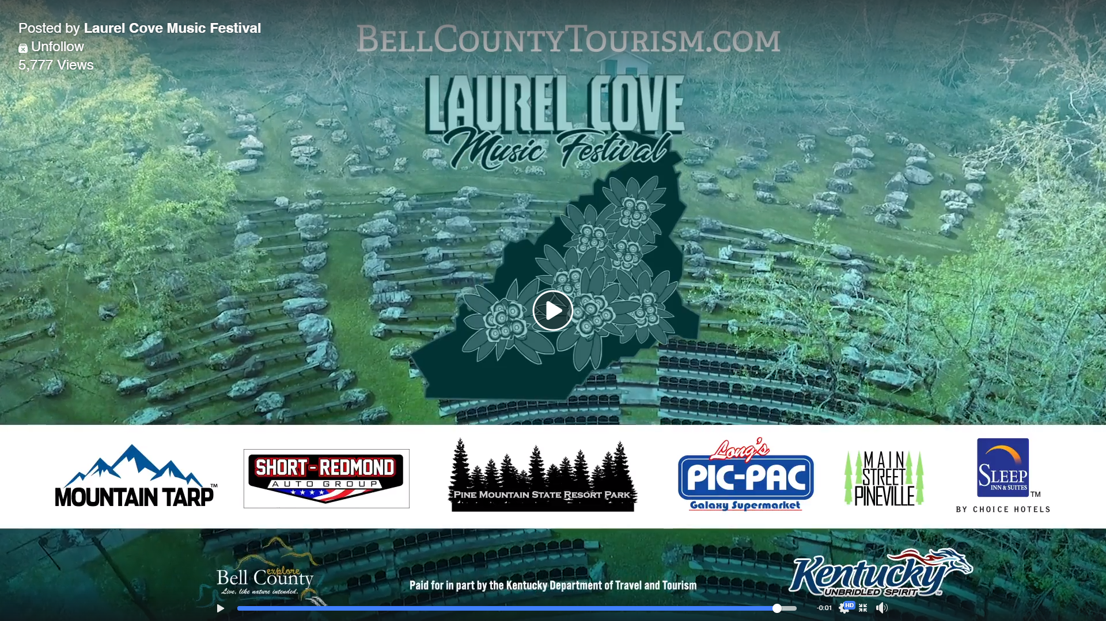

As you can see, you will be getting your value several times over in terms of the amount of exposure your company will gain by supporting this festival. We know that to grow this event to the level we expect, we must show the companies that believe in us that we will reciprocate their generosity to the fullest level possible. We know that sponsoring events at this level isn’t taken lightly, and we greatly appreciate your belief in the future of this event. We’ve learned so much in a few short years and have already begun to tighten up the plans for this year. We believe this event has the chance to be truly special and evolve into one of the finest music festivals in the entire state. With quality live music being played all over Kentucky at various events and festivals, we want to separate ourselves by showcasing the absolute best up and coming talent in one of the truly unique venues in the entire Commonwealth. Put simply, there’s nothing out there like Laurel Cove Music Festival.
Due to advertising deadlines, our sponsorship deadline is May 1^{st.} . Sponsorship spots are limited due to us wanting to be able to effectively market/promote the company. Spots are first come first serve.
If you are interested, just fill the brief form below out. For more information you can email me at jon@bellcountytourism.com or call/text me at 606-499-0567. We will need a high-res image of your company logo in PNG form only emailed to the aforementioned email (let us know if you need assistance in this).
You can cut out the form below and mail it with a check for sponsorship to. Memo on check should read “Laurel Cove Sponsorship Package”. We will return email with invoice and W9:
Bell County Tourism / 2215 Cumberland Ave / Middlesboro, KY 40965
You may also email us the following info and only mail check. You can also PayPal jon@bellcountytourism.com
------------------------------------------------------------------------------------------------------------------------------------------
Company Name: ________________________________________
Authorized Representative Name: _______________________________
Authorized Representative Signature: _______________________________
Contact Email: _______________________ Contact Phone: ____________________

Sponsor Level Desired (Please Check Box):
☐Diamond Sponsor ($10,000 – only one available) ☐ Platinum Sponsor ($5,000)

☐ Gold Sponsor ($2,500) ☐ Silver Sponsor ($1,000) ☐ Bronze ($500)
__________________________________________________________________________________________
Additional Sponsorship Options (See Page 3 For Pricing and Info)
☐Creekside Stage Sponsor ☐ Hospitality Sponsor ☐ Green Room Sponsor

☐ Event Program Sponsor ☐ Event Banner Sponsor ☐ VIP Area Sponsor ☐ Rack Card/Poster Sponsor

Notes From Sponsor (Optional):
Laurel Cove Music Festival Reviews
Hippies and Cowboys: “Bell Co, KY (Southeast Kentucky) is home to one of the finest music scenes in the entire country, and the jaw dropping mountain scenery that will have you counting down the days until you return.”
https://www.thehippiesandcowboys.com/blog/q43f54sj7geqtzkd6k4gy0xl50c9xt

Capture Kentucky: “If you’ve never heard of Laurel Cove, I beg of you to make a trip to this hidden gem nestled in the hills of Pineville, Kentucky. It’s truly a Kentucky treasure.”
https://www.capturekentucky.com/rain-aint-no-thang-day-one-of-the-laurel-cove-music-festival-in-pineville/
https://www.capturekentucky.com/attack-of-the-mothra-day-two-of-the-laurel-cove-music-festival-in-pineville/

Middlesboro Daily News: “Seats were full early on Friday with attendees from all over the country, and despite the rain, everyone was having a blast. It is evident that our community has found a gem with this event.”
https://www.middlesboronews.com/2021/06/15/thats-a-wrap-laurel-cove-music-festival-is-a-hit/

Wide Open Country: “Held in Pineville, Ky. at the Laurel Cove Amphitheater inside Pine Mountain State Resort Park, the festival has quickly garnered appreciation from artists and fans alike for its gorgeous Appalachian Mountain scenery and focus on highlighting some of the best regional and up-and-coming songwriters in the business.”
https://www.wideopencountry.com/laurel-cove-music-festival-2022/

The Amp: “While there, I heard someone refer to this spot as “the Red Rocks of Appalachia” and that has been how I mostly describe it when speaking in person. Among the many great venues and festivals in the Bluegrass state, this one stands out for its incredible display of staging and the lineup.”
https://turnuptheamp.com/home/2022/10/19/laurel-cove-music-festival-2022

Saving Country Music: “Over the last few years, we all haven’t been able to stop harping on all the great country music talent coming out of the greater Appalachian region, from Kentucky, to West Virginia, to the Commonwealth, to south and eastern Ohio. One festival with its finger squarely on the pulse of all of this has been doing their level best to put all that talent together in one place.”
https://www.savingcountrymusic.com/laurel-cove-music-festival-offers-best-of-appalachian-roots/

Commonwealth Country: “Very few music festivals provide this level of talent and value to fans. But it’s not just the price or the subjective assessment of musical quality that makes Laurel Cove stand out. The fellowship among the artists and fans genuinely makes it such a uniquely memorable event. There was a tangible aura of musical brotherhood throughout the weekend...”
https://commonwealthcountrymusic.com/2022/09/03/festival-feature-highlights-laurel-cove-music-festival-2022-gallery/

2022 Attendee Reviews
